# **Introducing Maven project**

1. Create New 🡪 Project and select Maven project

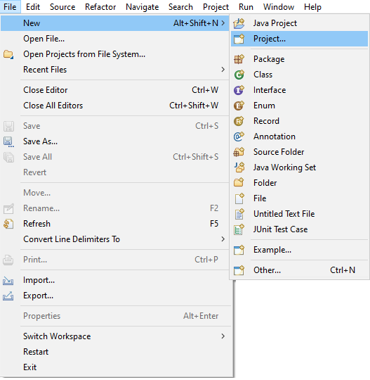

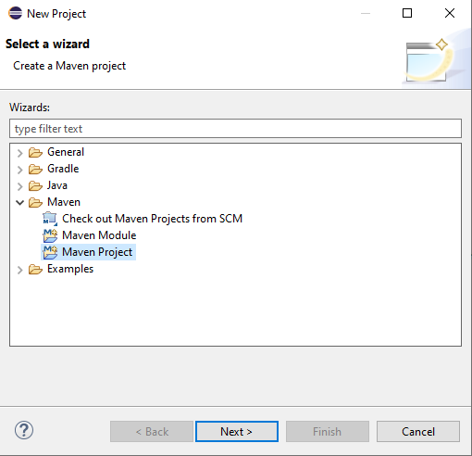

1. Select ‘Create a simple project (skip archetype selection)’. Give a name and click finish.

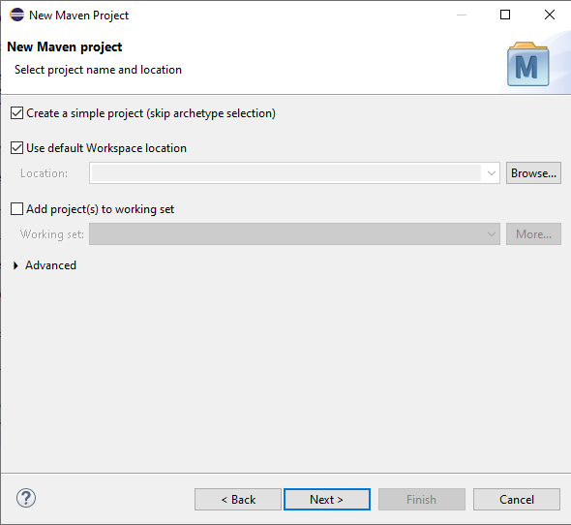

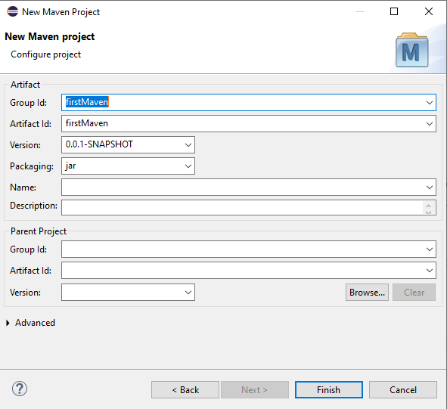

1. Expand the project you just created 🡪 open pom.xml and add maven repository configuration.

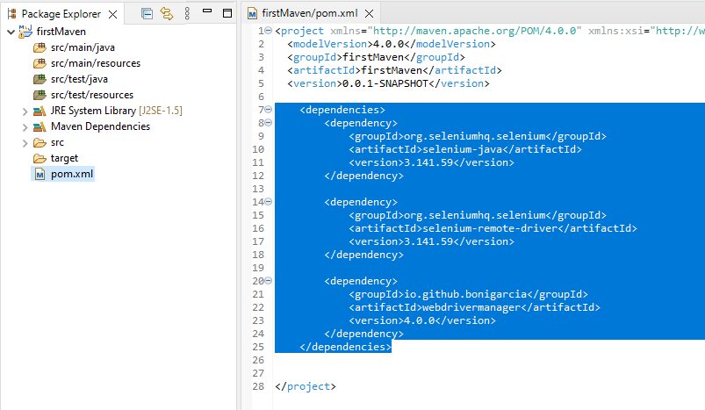

1. Right click on src/main/java folder 🡪 New 🡪 Class

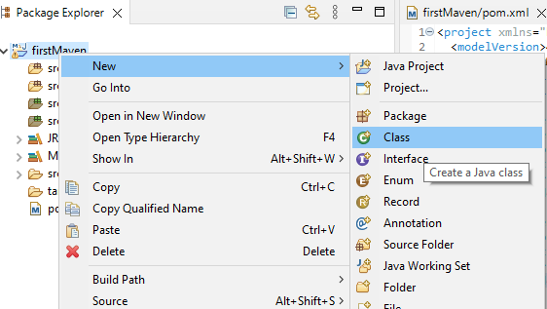

1. Provide Name, select ‘public static void main (String[] args) fields.

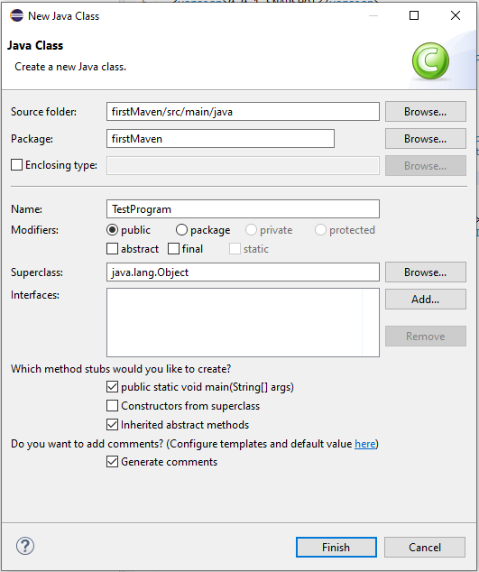

1. Code it as below to open Chrome browser and search with a test and display the search result.

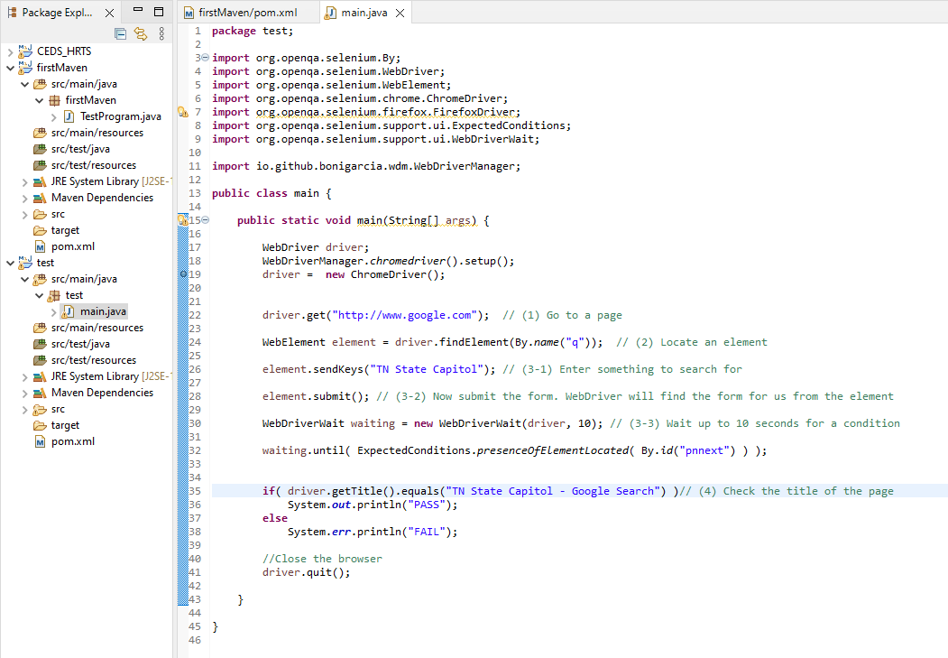

1. To run this, right click on the program file (example: main.java) 🡪 Run As 🡪 Java Application.

